Guidelines for Writing the Document

- The document should follow scientific writing principles. For help and guidance read: Science research writing for non-native speakers of English.
- The whole document must carefully be proofread for grammatical mistakes and typos. Students must submit signed document completed in all aspects. In addition, a plagiarism report must be attached at the end of the document.
- The Title of the document should be selected carefully because it cannot be changed later, and it must reflect the objectives of the study. It should be focused and oriented to exhibit the nature of the study.
- For Heading Level-1, use Font: Times New Roman, Size 12, Bold.
- For Heading Level-2, use Font: Times New Roman, Size 11, Bold.
- For Heading Level-3, use Font: Times New Roman, Size 11, Bold, Italicize.
- All Headings/Sub-headings must be properly numbered except “Summary of the Research”.
- Text in each section must follow Font: Times New Roman, Size 12 with Line Spacing:1.5.
- All Figures and Tables must be properly captioned in camel notation. For Figures, the caption must be at the bottom whereas, for Tables, the caption must be at the top. The caption of the Figure/Table must be of Font: Times New Roman, Size 10, See Example Below:
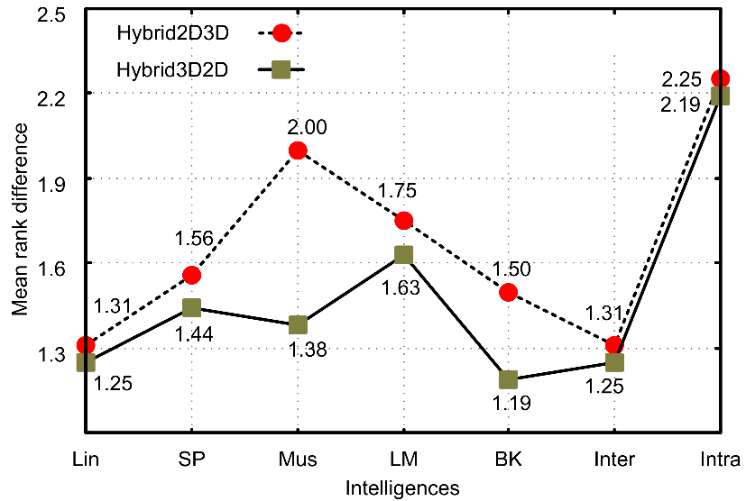
Figure. 1. Intelligences Mean Rank Differences

Table 1. List of Methodologies used for Classifying WBC datasets
Author | Year | Methods | Method Type | Dataset | Accuracy
Kutlu et al [16] | 2020 | Resnet50-CNN model with selective search, SSD, YOLOV3 deep models | Detection + Classification | BCCD, LISC | 97.52%
Baink et al [37] | 2020 | Color space transformation, K-mean clustering algorithm, CNN | Segmentation + Classification | BCCD | 98.61%, 96.00%
Gupta et al [32] | 2019 | OBBA, KNN, Logistic regression, RF, Decision based Tree classification | Classification | LISC | 97.30%

- All the Figures and Tables must be properly cross-referenced and explained in the text.
- The content inside tables must be of Font: Times New Roman, Size 10.
- The figures must have good resolution and the content of the figure must be readable.
- There must be some text between two consecutive headings/ sub-headings.
- For References use IEEE standard referencing style and citation must be accordingly. For reference use Font: Times New Roman, Size 11 with Line Spacing: Single
- Carefully read all the items in the front pages and last pages and fill them accordingly.
- Before submission the document must be duly signed by student, members of the supervisory committee, and members of the advisory committee.
- Please specify the list of courses studied during the degree in the designated area in the document.
- The literature review section should include research articles published in impact factor Journals or conferences with high impact score (https://research.com/conference-rankings/computer-science).

